Sanjana Kulkarni

*by* Turnitin LLC

Submission date: 18-Feb-2024 10:14AM (UTC+0100)

Submission ID: 2297552767

File name: ZzKCqlg5RmR-Crop-Yield-Prediction-using-Satellite-Imagery-1.docx (225.84K)

Word count: 5143

Character count: 27601

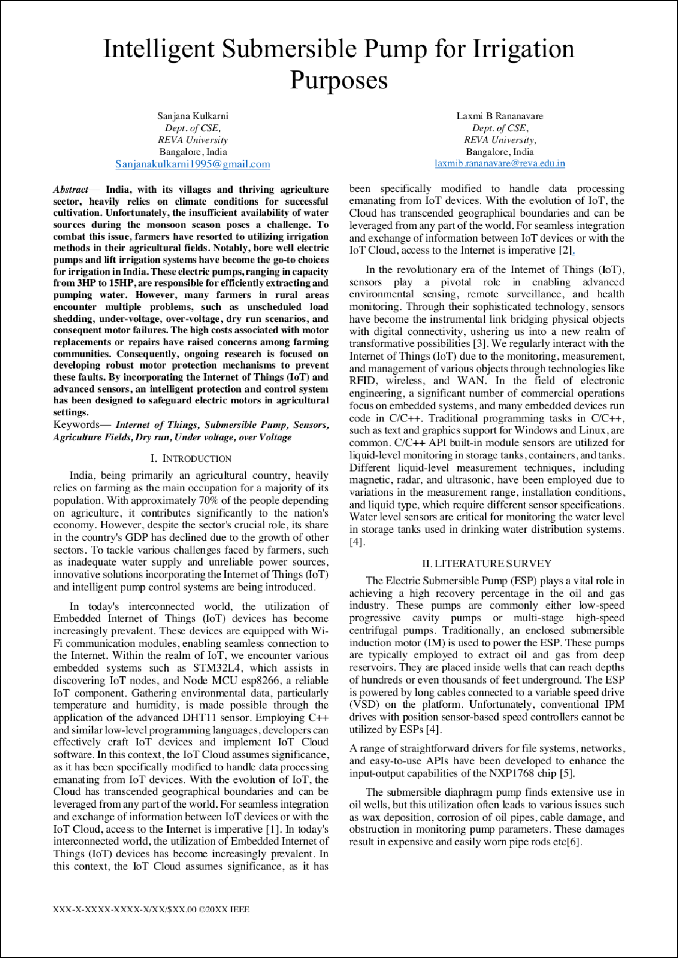

13

30

31

40

39

18

18

18

27

27

19

19

28

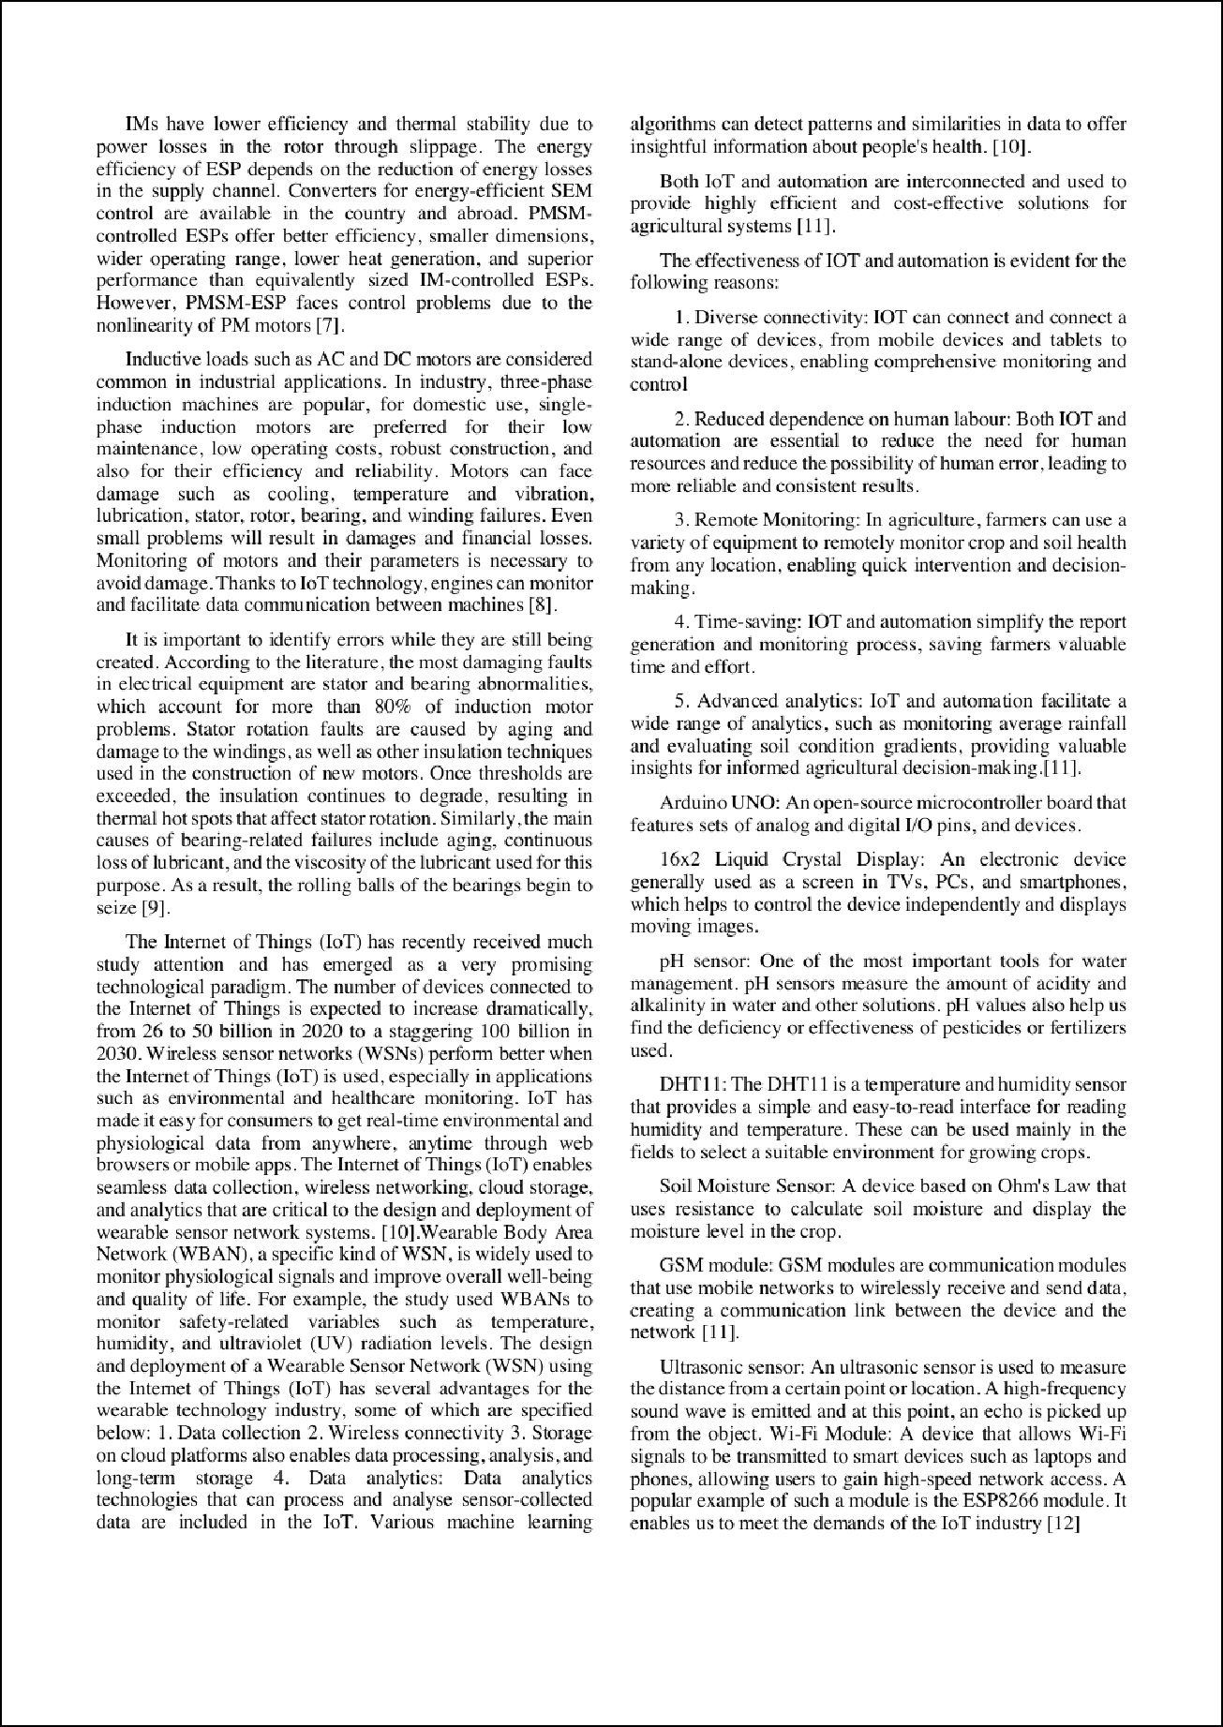

19

38

29

41

23

24

33 32

17

17

17

35

17 34

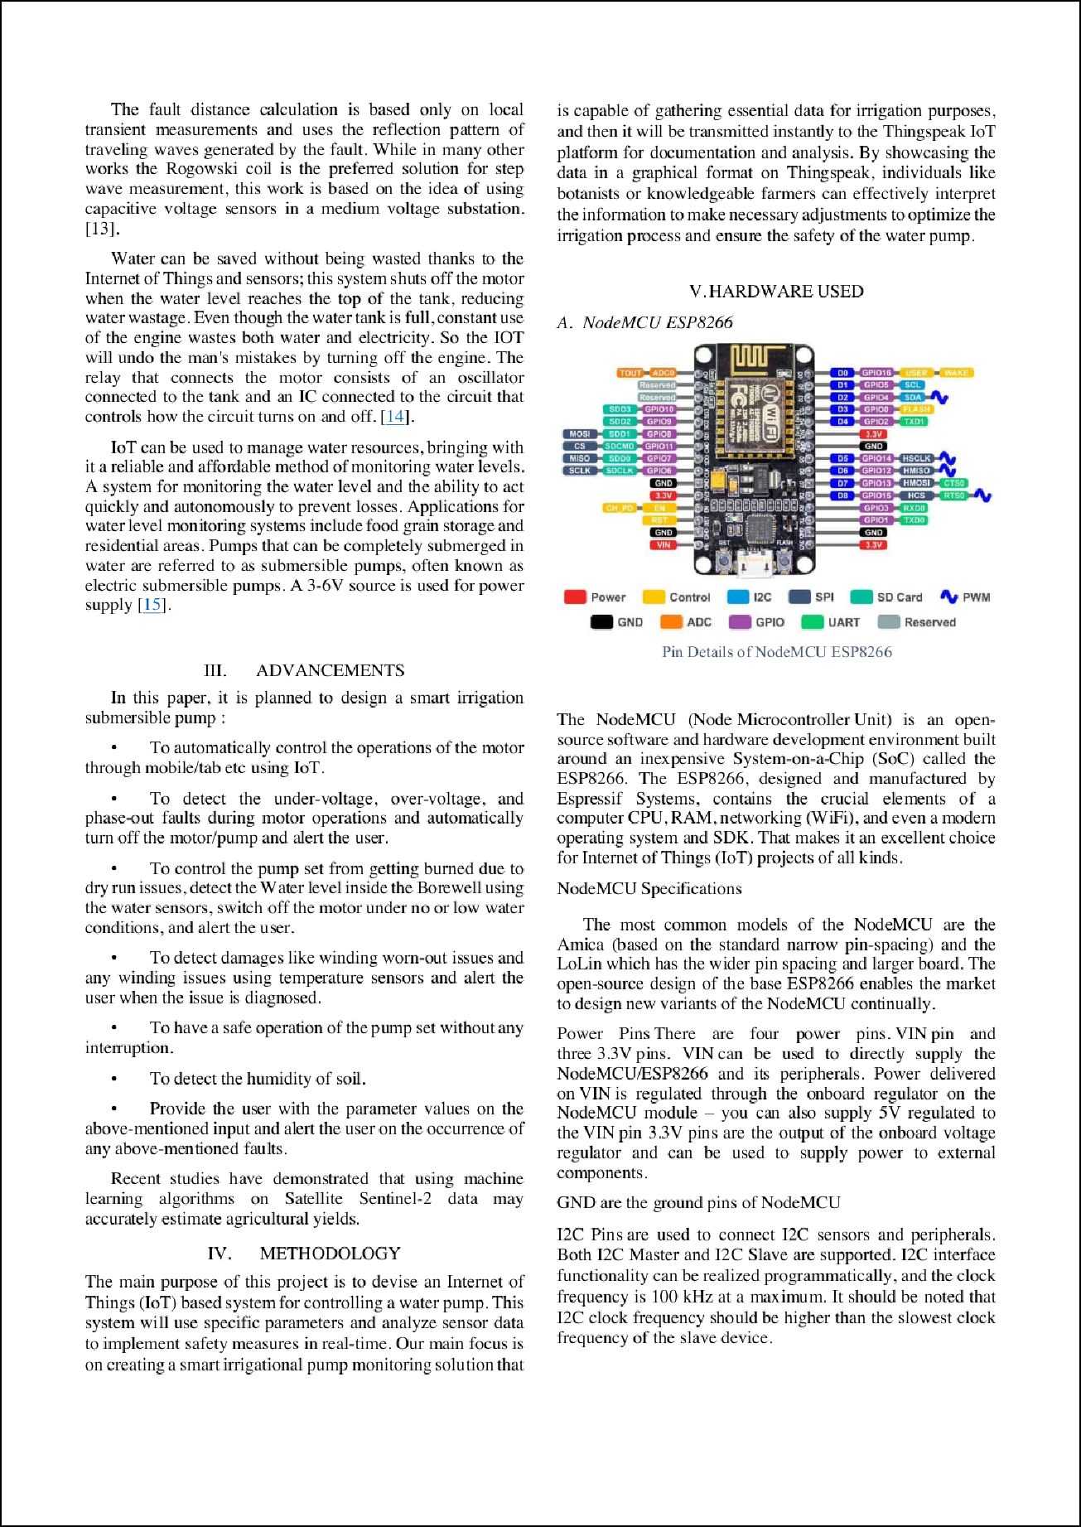

16

16

21

21

21

37

26

8

1

1

13

25

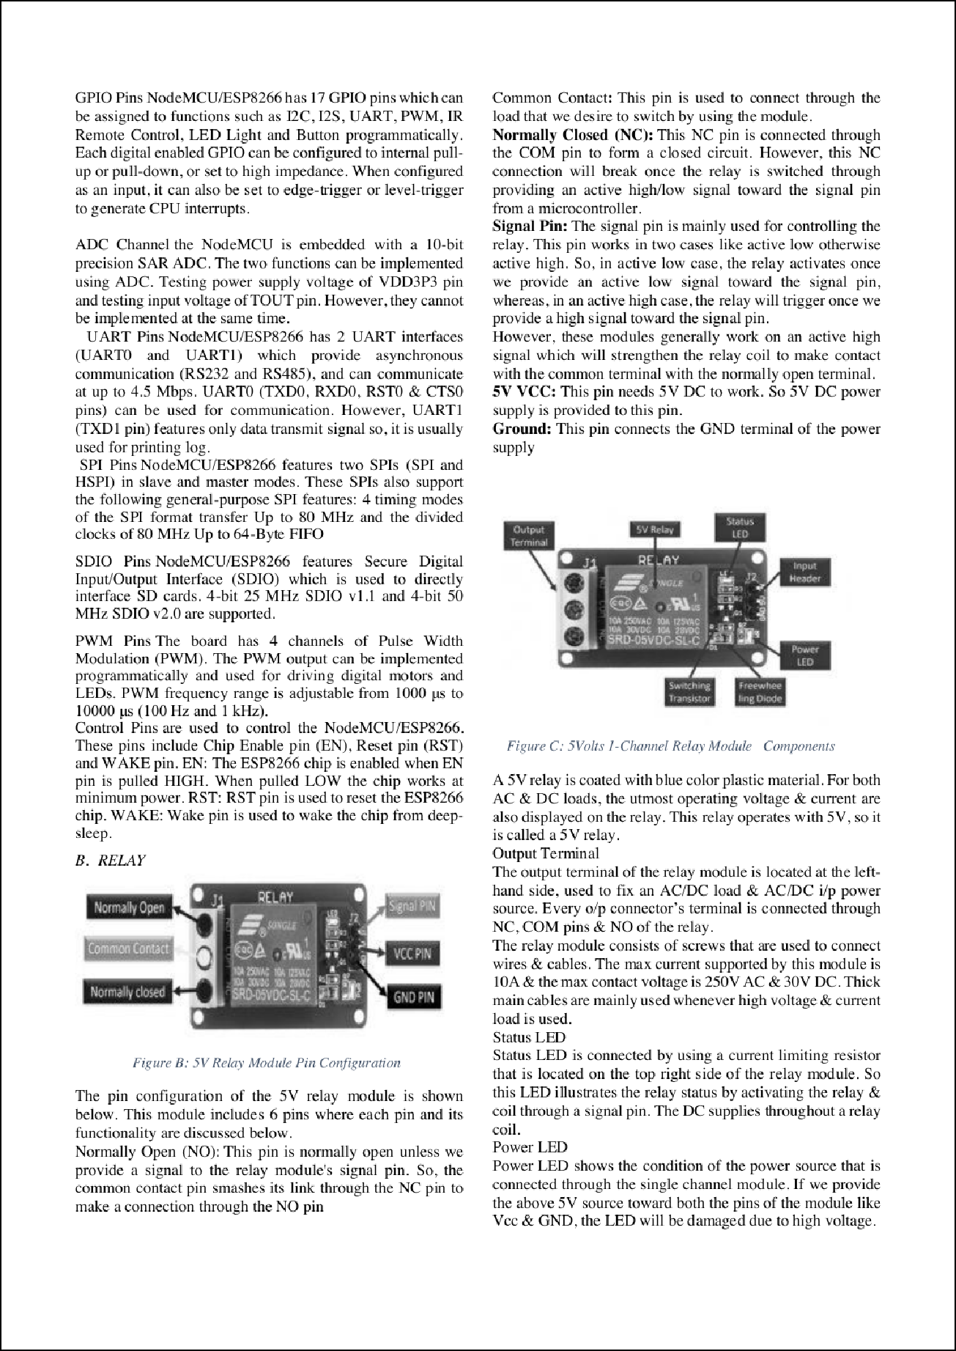

|  |  |
| --- | --- |
|  | |
|  | |
|  | |
|  | |
|  |  |
|  |

10

7

20 6

10

6

2

10

6

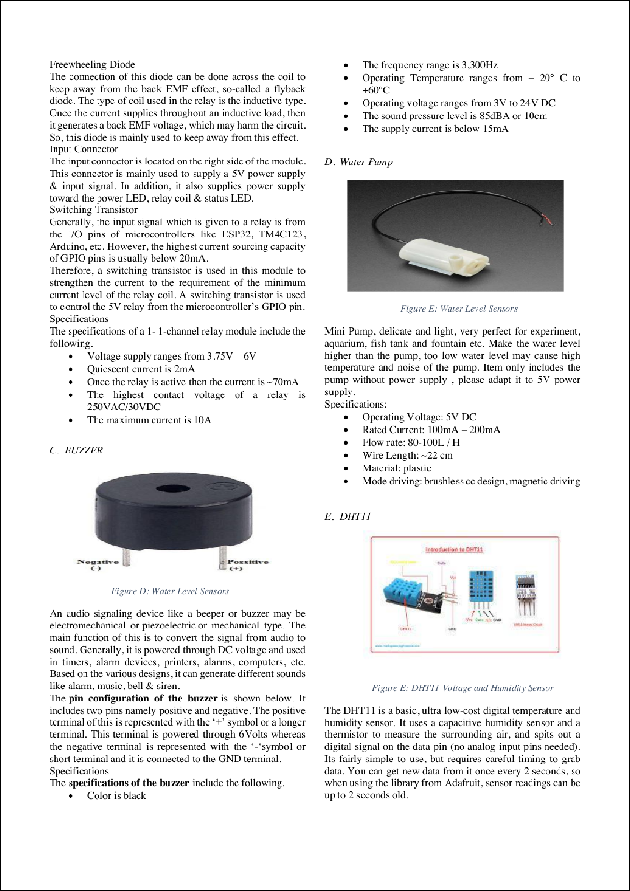

6

11

10

22

11

14 12

36

4

3

15

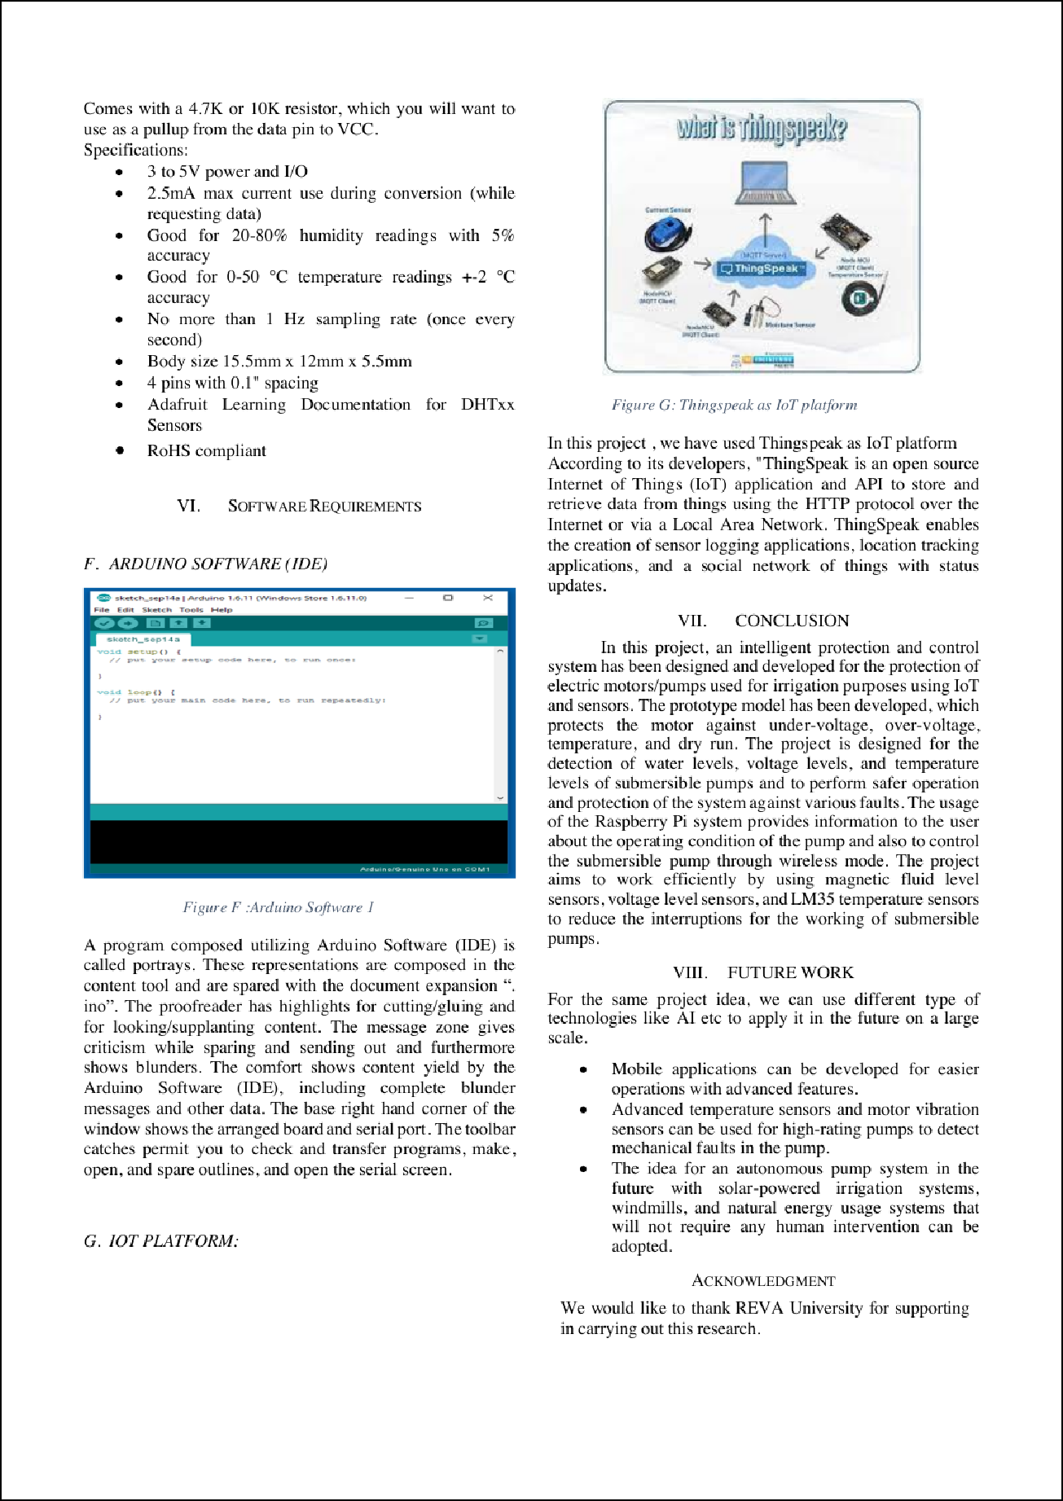

9

5

|  |  |
| --- | --- |
|  | |
|  | |
|  | |
|  | |
|  | |
|  | |
|  | |
|  |  |
|  |

13

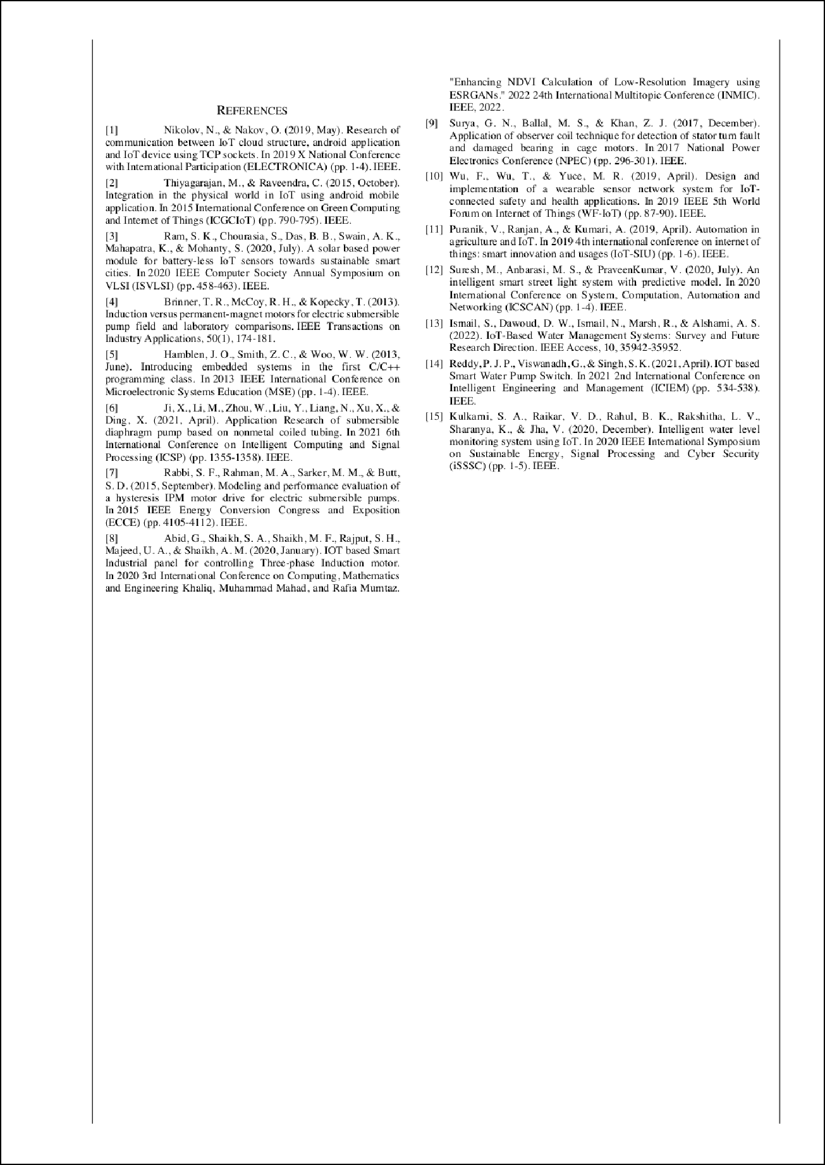

Sanjana Kulkarni

47

ORIGINALITY REPORT

%

SIMILARITY INDEX

41%

INTERNET SOURCES

18%

PUBLICATIONS

31%

STUDENT PAPERS

PRIMARY SOURCES

sist.sathyabama.ac.in

1

Internet Source

suspace.su.edu.bd

2

Internet Source

github.com

3

Internet Source

ijareeie.com

4

Internet Source

pdfcoffee.com

5

Internet Source

[www.ijnrd.org](http://www.ijnrd.org/)

6

Internet Source

iarjset.com

7

Internet Source

ijrpr.com

8

Internet Source

[www.ijresm.com](http://www.ijresm.com/)

9

Internet Source

11%

5%

4%

3%

2%

2%

2%

2%

1%

10

11

12

13

14

15

16

17

[www.lewiscountyherald.com](http://www.lewiscountyherald.com/)

Internet Source %

1

microcontrollerslab.com

1

Internet Source %

rees52.com

1

Internet Source %

Laxmi B Rananavare, Sanjay Chitnis. "Crop Yield Prediction Using Satellite Imagery", 2023 7th International Conference on Computation System and Information Technology for Sustainable Solutions (CSITSS), 2023

1%

Publication

sungood.shop

1

Internet Source %

Submitted to Somaiya Vidyavihar

1

Student Paper %

Björn Martin Keune, Michael Kleemann, Christian Rehtanz. "Capacitive voltage sensors for an auxiliary fault locating service with travelling waves", CIRED - Open Access Proceedings Journal, 2017

1%

Publication

Fan Wu, Taiyang Wu, Mehmet Rasit Yuce. "Design and Implementation of a Wearable Sensor Network System for IoT-Connected Safety and Health Applications", 2019 IEEE

1%

18

19

20

21

22

5th World Forum on Internet of Things (WF- IoT), 2019

Publication

Konstantinos Loizou, Eftichios Koutroulis, Dimitrios Zalikas, Georgios Liontas. "A low- cost capacitive sensor for water level monitoring in large-scale storage tanks", 2015 IEEE International Conference on Industrial Technology (ICIT), 2015

Publication

S. F. Rabbi, M. Constantine, M. A. Rahman. "A novel sensorless IPM motor drive for electric submersible pumps", 2017 IEEE International Electric Machines and Drives Conference (IEMDC), 2017

Publication

lms.pba.umt.ac.id

Internet Source

Peddamallu Jaya Prakash Reddy, Guntimadugu Viswanadh, Sanjay Kumar Singh. "IOT based Smart Water Pump Switch", 2021 2nd International Conference on Intelligent Engineering and Management (ICIEM), 2021

Publication

rfnq.mokotowwings.pl

Internet Source

1%

1%

1%

1%

<1%

23

24

25

26

27

28

29

28b15.budzianowski.eu

Internet Source

Girish Kalele. "An In-Depth Examination of Traditional, Blockchain, and AI-Based Key- Security for The Cyber-Physical IoT Networks", 2023 3rd International Conference on Advance Computing and Innovative Technologies in Engineering (ICACITE), 2023

Publication

Jing Zhang, Chen Pan, Shuhua Liu, Yanjun Kou, Jian Tang, Yafei Wang, Ning Yang, Rubing Huang. "Crop Disease Source Location and Monitoring System Based on Diffractive Light Identification Airborne Spore Sensor Network", IEEE Internet of Things Journal, 2022

Publication

Submitted to University of Regina

Student Paper

"Security-Related Advanced Technologies in Critical Infrastructure Protection", Springer Science and Business Media LLC, 2022

Publication

[www.researchgate.net](http://www.researchgate.net/)

Internet Source

Gulamfaruk N. Surya, Makarand S. Ballal, Zafar J. Khan. "Application of observer coil

<1%

<1%

<1%

<1%

<1%

<1%

<1%

30

31

32

33

34

35

technique for detection of stator turn fault and damaged bearing in cage motors", 2017 National Power Electronics Conference (NPEC), 2017

Publication

Shabeena Lylath, Laxmi B Rananavare. "Efficient Approach for Autism Detection using deep learning techniques: A Survey", 2022 IEEE 3rd Global Conference for Advancement in Technology (GCAT), 2022

Publication

Zulfadli Hazim Zul Azlan, Syahrul Nizam Junaini, Noor Alamshah Bolhassan, Rafeah Wahi, Mohammad Affendy Arip. "Harvesting a sustainable future: An overview of smart agriculture's role in social, economic, and environmental sustainability", Journal of Cleaner Production, 2023

Publication

businessdocbox.com

Internet Source

[www.i-scholar.in](http://www.i-scholar.in/)

Internet Source

[www.imanagerpublications.com](http://www.imanagerpublications.com/)

Internet Source

Marco Tani, Lorenzo Parri, Ada Fort, Marco Mugnaini, Valerio Vignoli, Alberto Toccafondi,

<1%

<1%

<1%

<1%

<1%

<1%

36

37

38

39

40

41

Riccardo Moretti, Elia Landi. "Distributed IoT system to enhance worker safety in large open areas", 2021 IEEE International Instrumentation and Measurement Technology Conference (I2MTC), 2021

Publication

community.element14.com

Internet Source

eurchembull.com

Internet Source

ijsred.com

Internet Source

openaccess.altinbas.edu.tr

Internet Source

[www.ijrte.org](http://www.ijrte.org/)

Internet Source

Ismail Keshta. "AI-driven IoT for smart health care: Security and privacy issues", Informatics in Medicine Unlocked, 2022

Publication

<1%

<1%

<1%

<1%

<1%

<1%

Exclude quotes Off Exclude bibliography On

Exclude matches Off